✅ MYFUTURE+ LESSON PLAN
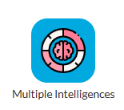
Understanding Yourself through the Multiple Intelligences Quiz
Section 1: Understanding and Developing Yourself
Duration: 45 Minutes
Programme: MyFuture+ / Multiple Intelligences

🎯 Learning Outcomes
Students will:
- Understand the concept of Multiple Intelligences
- Identify their strongest intelligences
- Link intelligences to careers and learning
- Reflect on their results

🟢 Introduction (10 minutes)
Teacher Discussion:
- What is intelligence?
- How do we measure it?
- Explain: Intelligence is the ability to learn, solve problems and adapt.

🟡 Activity 1 – Guess Your Top Intelligences (10 mins)
Students predict their strongest intelligence before completing the questionnaire.

🟡 Activity 2 – Complete Questionnaire (20 mins)
Steps:
1. Open Multiple Intelligences Questionnaire
2. Answer honestly
3. Identify top intelligence type

🟣 Activity 3 – Career Exploration (10 mins)
Students match intelligence to careers and sectors.

🔴 Reflection Activity (10 mins)
- Were you surprised?
- What careers suit you?
- What did you learn?

✅ Success Outcomes
Students can identify their top intelligence types and link to careers and famous people.

📊 Assessment for Learning
Observation, worksheet, reflection.

🎯 Universal Design for Learning
Support: discussion, printed materials
Extension: Research careers based on the top type.

📚 Resources Needed
Devices, questionnaire, worksheet.
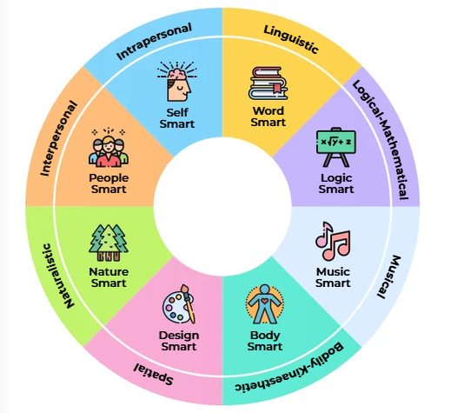

Videos: Embedded in PowerPoint


5-minute video explaining Gardner's Multiple Intelligences Theory with fictional TV and Movie Characters.

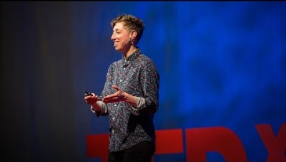
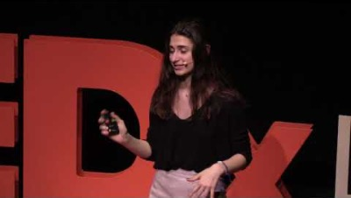
6-minute Ted Talk video. Writer and artist Emilie Wapnick describes the kind of people she calls "multipotentialites”.
12-minute Ted Talk video. Celeste Tomaselli explains how Gardner's Theory of Multiple Intelligences can empower young people to use their unique talents to make the world a better place.

